
QUALITY ALERT

Customer: United Date: Jan 29, 2026
Die: 15342-15138-15139-15144-15252-15253-15258-15703
Colour: WH-136
Type of Complaint: Customer REJECTED

Q.A # 26-008 NCR: 049 RMA#: N/A

Description: Customer reported jamb too tight. Channel height measured below drawing specification, causing excessive force during balance insertion and difficult window operation.
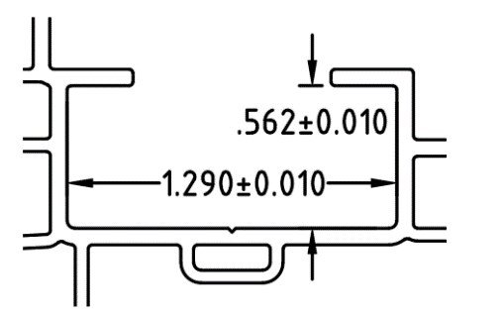
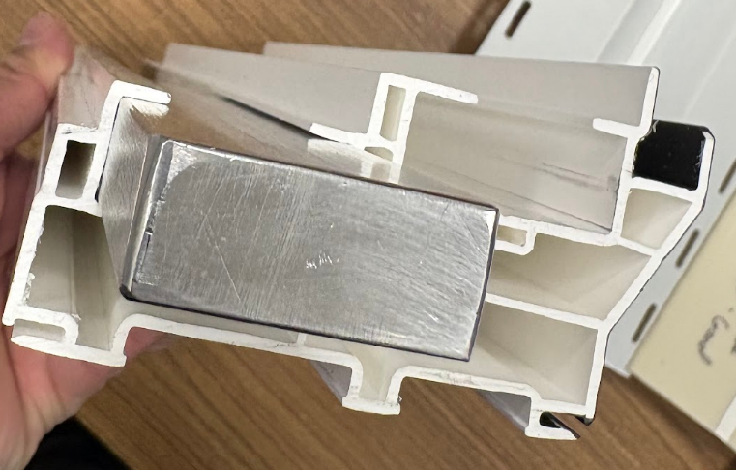


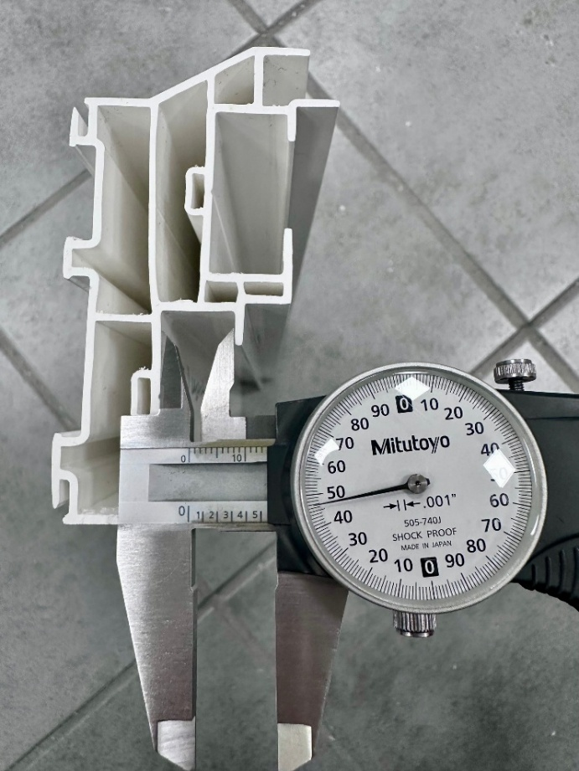
ENSURE ALL POCKET DIMENSIONS ARE WITHIN THE ALLOWABLE TOLERANCES ± 0.010, INTERNAL WALLS ARE STRAIGHT, AND FUNCTIONAL CHECK MUST BE PERFORMED USING GO-NO-GO PIECE
MUST FOLLOW TOLERANCES STRICTLY
GO-NO-GO MUST FITS IN

BY SIGNING BELOW, YOU ACKNOWLEDGE THE PROBLEM ABOVE AND AGREE TO MONITOR THIS ISSUE IN FUTURE PRODUCTION RUNS.
DAY SHIFT |  | AFTERNOON SHIFT |  | NIGHT SHIFT
NAME | SIGNATURE | NAME | SIGNATURE | NAME | SIGNATURE
F-006: Quality Alert | Eff.Date: 05/03/2025 | CC# 25-046 | Rev.0

